Mud Management
By Ashlynn Noble & Chris Wickliffe, DVM
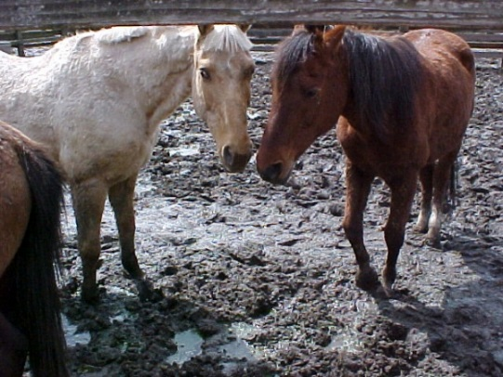

It’s that time of year again! The rain has returned and with rain comes mud. Did you know that western Oregon and Washington average between 35-47 inches of rain per year? And while the Central and Eastern parts of Oregon and Washington get significantly less, that doesn’t mean that they are immune to the mud.

Mud management for our horses is very important because mud leads to excessive moisture against the skin and is a great breeding ground for bacteria and fungus. Chronic exposure to these can lead to hoof abscesses, mud fever and/or thrush.

Hoof abscesses are very common in western Oregon and Washington. They are caused by bacteria entering a crack, puncture or defect in the hoof wall or sole. Anaerobic bacteria then start to grow in this area causing inflammation and sudden lameness. This painful problem can make a horse go from trail riding one day to barely able to walk the next. Superficial abscess can often be cured with soaking the foot in hot water and Epsom salts. But often a farrier or veterinarian visit will speed the healing process and help prevent reoccurrence. A reoccurring or deep abscess should always be seen by a veterinarian or a farrier to decide on the appropriate treatment plan.

Mud fever, also known as scratches, is another problem brought on by mud. It is caused by a mixture of fungal and bacterial that cause a skin infection that results in painful sores on the fetlock and pasterns of horses. They are more commonly found in horses that have feathers over their fetlocks and pasterns. This is because moisture gets trapped under the long hair and bacteria flourish in dark, warm, damp environments. Treatment includes clipping the area to allow drying. Cleaning with an anti-bacterial/fungal agent like chlorhexidine. Wrapping to minimize swelling, systemic antibiotics and anti-inflammatories. Often these are persistent but superficial infections. However, it is possible for scratches to lead to a systemic lymphangitis that is life threatening. So it is important for it to be seen by your veterinarian.

Hoof thrush is another common issue caused by bacteria that gives off that unwanted smell from a horses’ hoof that many of us are familiar with. Thrush occurs naturally and thrives in an unsanitary environment such as a muddy unpicked pasture or a dirty stall. It commonly affects the frog of the hoof due to the low amount of oxygen that reaches that part of the hoof. Mud is a breeding ground for bacteria so eliminating it from your paddock is beneficial for the health of your horses. Most farriers have a favorite way of treating thrush that works well in their area. Trust them, they are an essential part of your horse health team.

In addition, the excess moisture in mud causes soft hooves and soles which can lead to uneven wear on different parts of the hoof, hoof cracks, stretching of the white line and bruising of the sole. When horses are spending a lot of time in mud, the resulting soft hoof wall can wear down unevenly. This can lead to advanced problems such as long toes, short heels, and excessive solar pressure. When this happens the horse’s hoof will need to be slowly reconstructed by a farrier in order to make your horse comfortable and sound again. This can be an expensive and a very time-consuming process. It is best to try and avoid this by managing mud in your paddocks and pastures.

There are several methods for mud management. The most important thing to do is plan ahead. When designing a paddock/pasture choose high ground with natural water runoff this will help prevent pastures from building up with standing water. All paddock areas should be designed with a slope. You can slope your pastures at a 1-2 % grade to redirect water away from buildings or high traffic areas. When done correctly, sloping your pastures can be a very effective and cheap mud management strategy. Mud often happens in high traffic areas where water is unable to drain and therefore pools up. Raising these areas with geotextile cloth, rock and a drainage system is helpful. Installing a French drain around the outside of your paddocks is also a great option for management of excess water. A French drain is a trench that is dug along the paddock and filled with gravel. As water runs off into the drain, the trench then leads that water away from the paddock to a sacrifice area. This sacrifice area is commonly known as a riparian area designated for the excess water to run off.

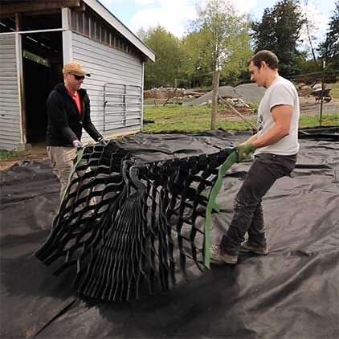
One of the best ways to fix a muddy pasture is to fill in the low spots where water accumulates and place down a footing grid system. This is a wonderful option. However, it can be costly as footing and grid systems are not cheap. Placing a grid system can be done many ways. An easy way to start is by placing a layer of geotextile cloth down over high traffic areas or the entire paddock if you choose. Once fabric is in place, a grid system is then placed, followed by about 6 inches of footing of your choice. Many people choose a sand or gravel mixture. This helps allow for proper drainage and keeps your paddock mud free.

Some additional options for mud management are to pick you pastures and rest your pastures on a rotation schedule if possible. Trampling causes compaction of the soil, loss of nutrients, and poor drainage ability. A good rule of thumb is one horse per acre. Rotating pastures will help keep the vegetation and nutrients in your pastures for many years to come.

There are many different footing options out there as well. Each footing has its own advantages and disadvantages. Some common footing choices are as follows; crushed rock, gravel, sand, shavings, straw, and hogs fuel (wood ships or shreds). Unfortunately, hogs fuel decomposes quickly over time and sand can cause other problems such as sand colic when accidently ingested. Gravel or crushed stone on the other hand can be a great choice, although it becomes uncomfortable for the horse to stand on if it is larger than 5/8”. On a budget you can use a mixture of several footings and apply gravel to the high traffic areas only. Just remember if your going to use any footing system make sure to put a geotextile cloth under it to ensure that water can run through without releasing mud to surface.

One last recommendation if you still have mud in your pasture. Find a clean dry spot, such as a stall, and put your horse in at night. This allows their feet and legs to dry out overnight. A great trick is to use bedding pellets or a mix of pellets and shavings. Pellets absorb a much greater amount of water then shavings and will help the feet dry faster.

All of us at Cascadia Equine Veterinary Clinic hope that all of you are having a wonderful fall and are making time to get out and enjoy our amazing northwest with your equine partners.

